CSA1715-ARTIFICIAL INTELLIGENCE

LAB PROGRAM- 9
30-07-2026

Write the python program to implement Travelling Salesman Problem.

Aim
To implement the Travelling Salesman Problem (TSP) using Python to find the minimum cost path that visits every city exactly once and returns to the starting city.

Algorithm
  - Read the number of cities.
  - Read the cost matrix.
  - Generate all possible routes using permutations.
  - Compute the total cost of each route.
  - Compare all route costs.
  - Store the minimum cost route.
  - Display the optimal path and minimum cost.

Program
from itertools import permutations

n=int(input("Enter number of cities: ")) g=[]

print("Enter the cost matrix:") for i in range(n):
g.append(list(map(int,input().split())))

mc=float('inf') bp=[]

for p in permutations(range(1,n)): c=0
k=0
for i in p: c+=g[k][i] k=i
c+=g[k][0] if c<mc:
mc=c bp=(0,)+p+(0,)

print("Minimum Path:",bp) print("Minimum Cost:",mc)

Input
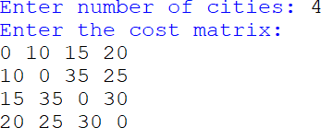

Output

Result:
The Travelling Salesman Problem was successfully implemented using Permutation Search. The program found the optimal route with the minimum travelling cost.

